CSA1555-Cloud Computing and Big Data Analytics for Education.

Kalikiri Jaswanth Reddy

Reg no:192124019

Lab Activity-Day2

**EXPNO 2: CREATE A VIRTUAL MACHINE WITH 1 VCPU, 2GB RAM AND 15GB**

**STORAGE DISK USING A TYPE 2 VIRTUALIZATION SOFTWARE**

AIM: To create a virtual machine with given specifications.

PROCEDURE:

**IMPLEMENTATION:**

**STEP 1:DOWLOAD VMWARE WORKSTATION AND INSTALLED AS TYPE 2**

**HYPERVISOR.** 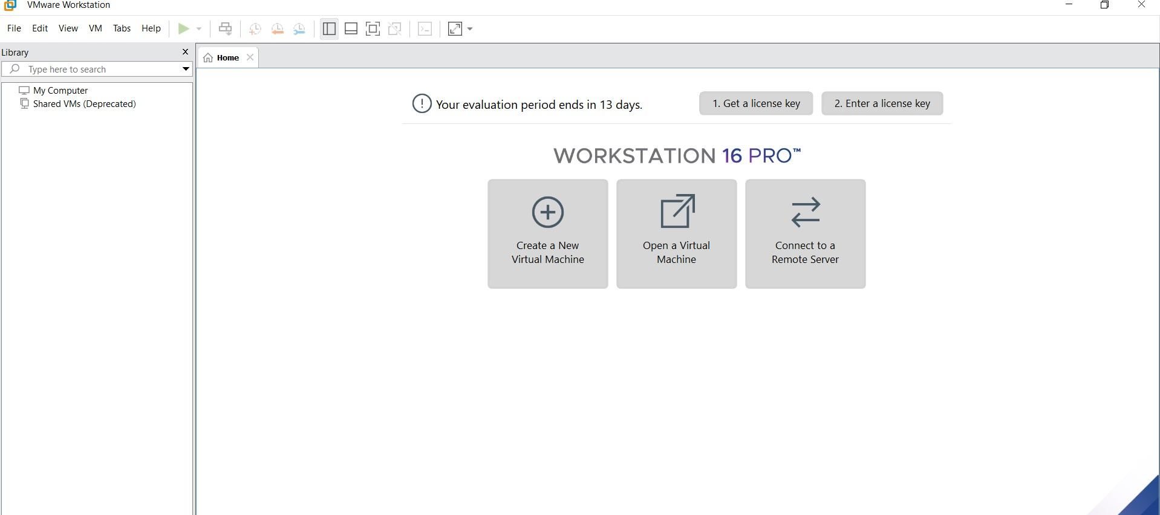

**STEP2: DOWLOAD UBUNTU OR TINY OS AS ISO IMAGE FILE**

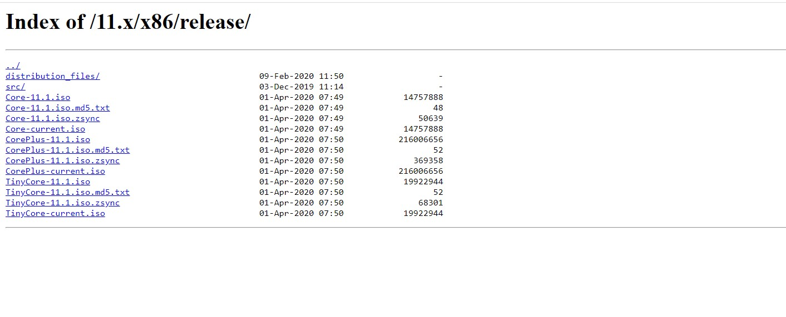 **STEP 3: IN VMWARE WORKSTATION->CREATE NEW VM**



**STEP 4: DO THE BASIC CONFIGURATION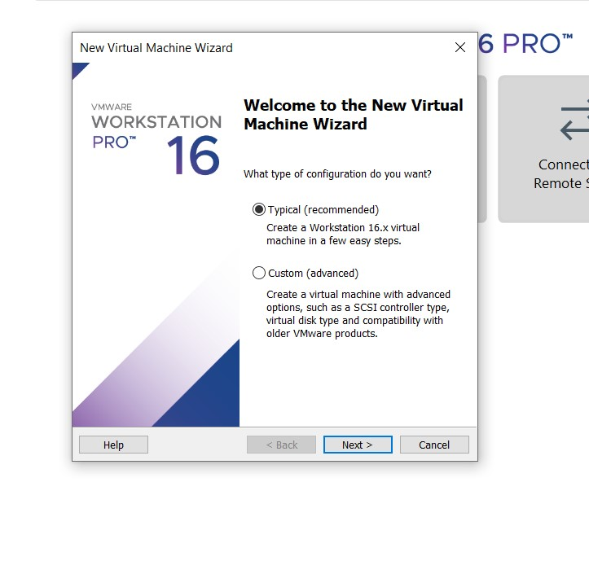 SETTINGS.**

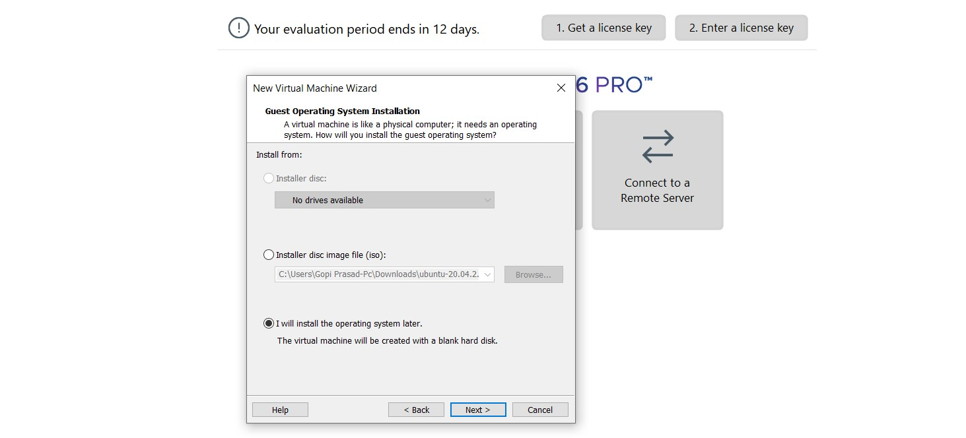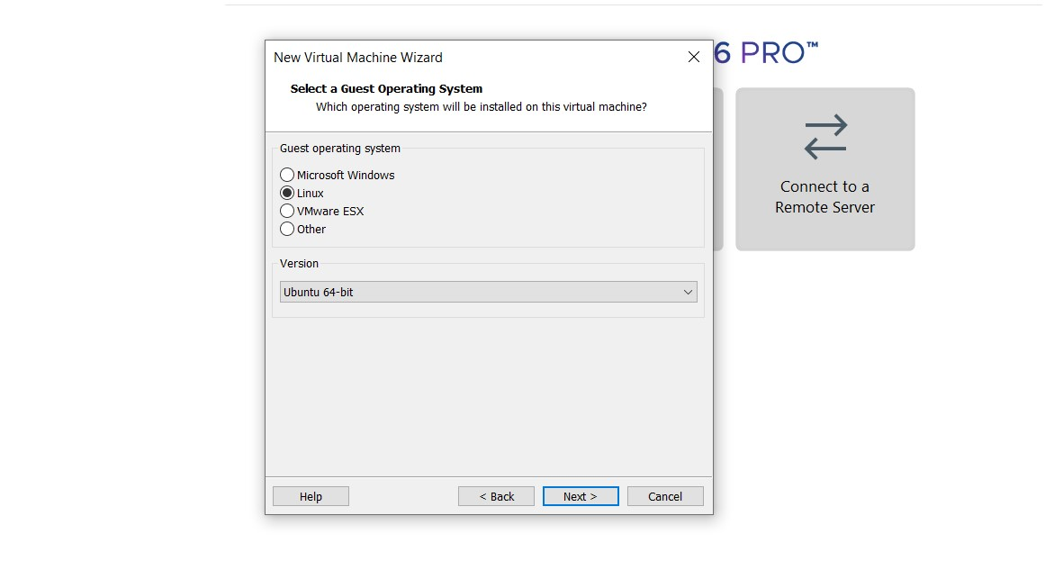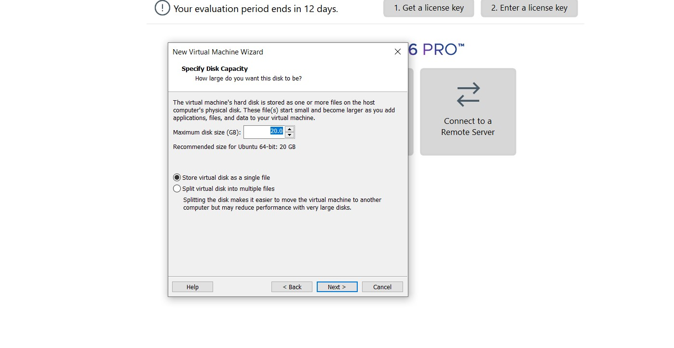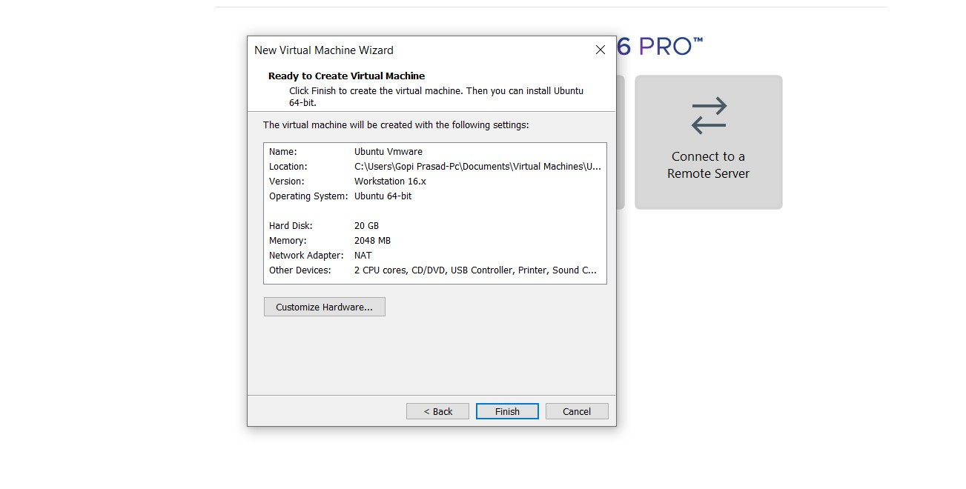

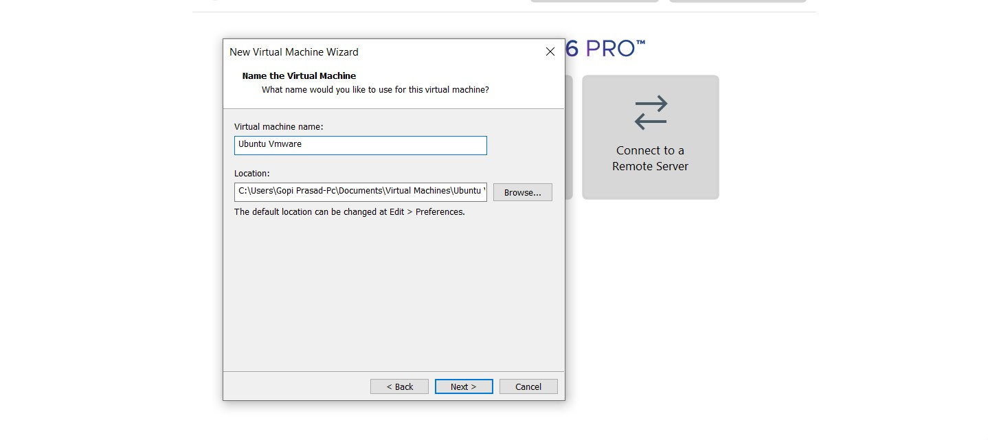 **STEP 4: CREATED TINYOS VIRTUAL MACHINE**

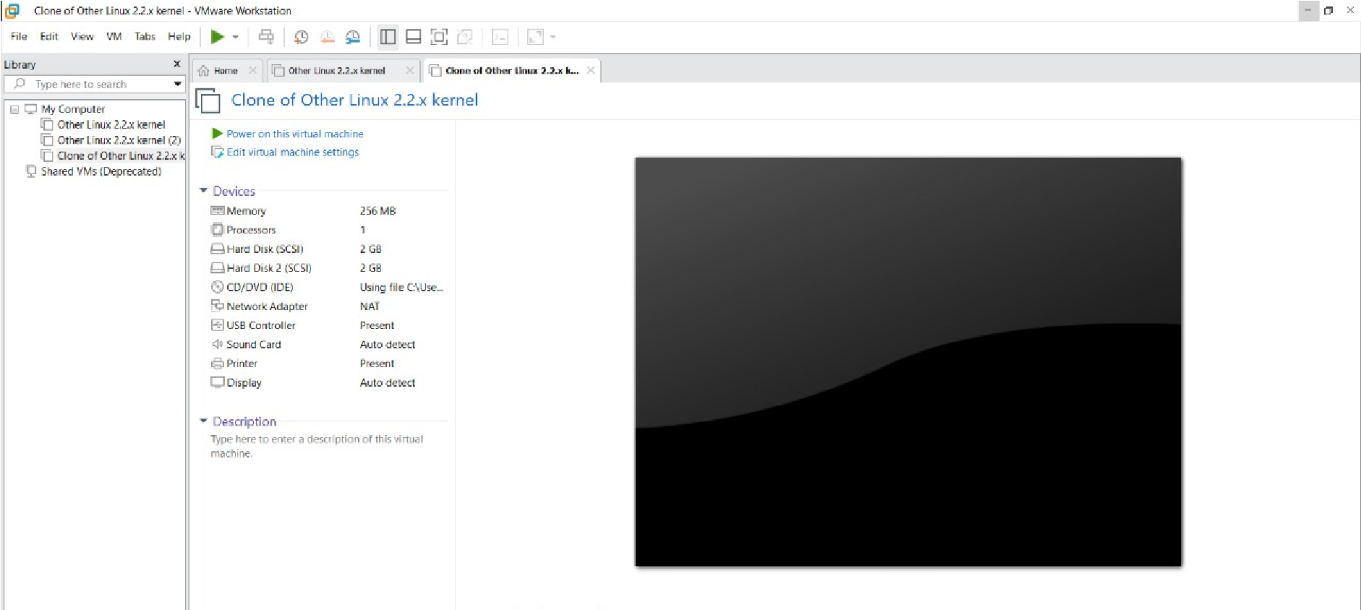 **STEP 5: LAUNCH THE VM**

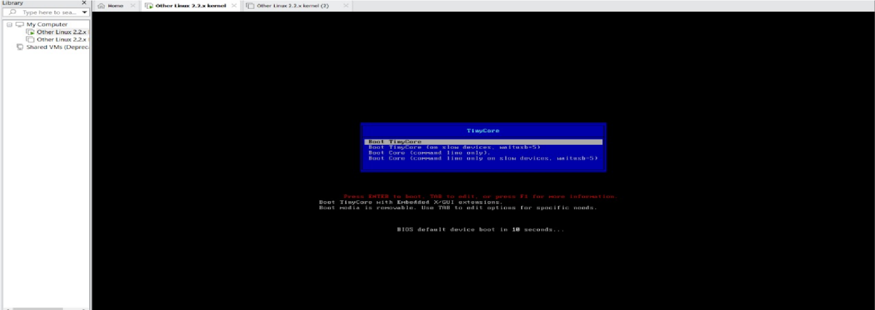

**RESULT:To create a virtual machine with given specifications.**

**EXP 3: CREATE A VIRTUAL HARD DISK AND ALLOCATE THE STORAGE**

**USING VM WARE WORKSTATION**

AIM:To create a virtual hard disk and allocate the specified storage.

PROCEDURE:

**IMPLEMENTATION:**

**STEP 1:**

**GOTO VM WARE WORKSTATION**

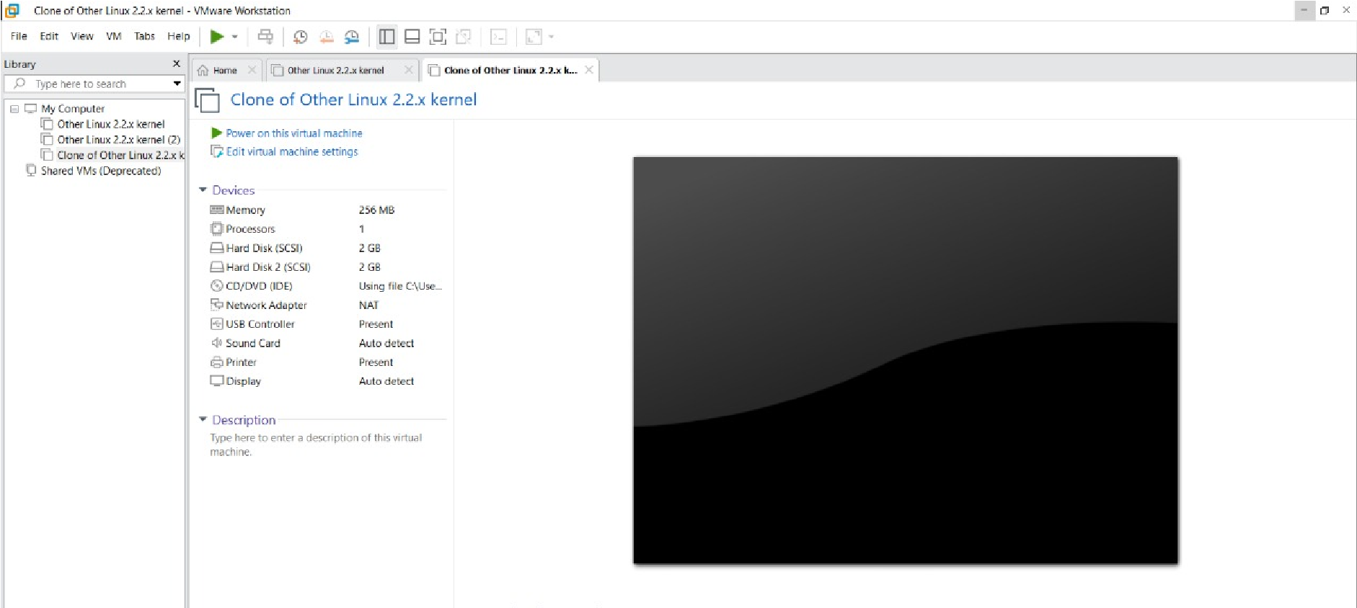 **STEP2: RIGHT CLICK THE VM AND GOTO THE SETTINGS**

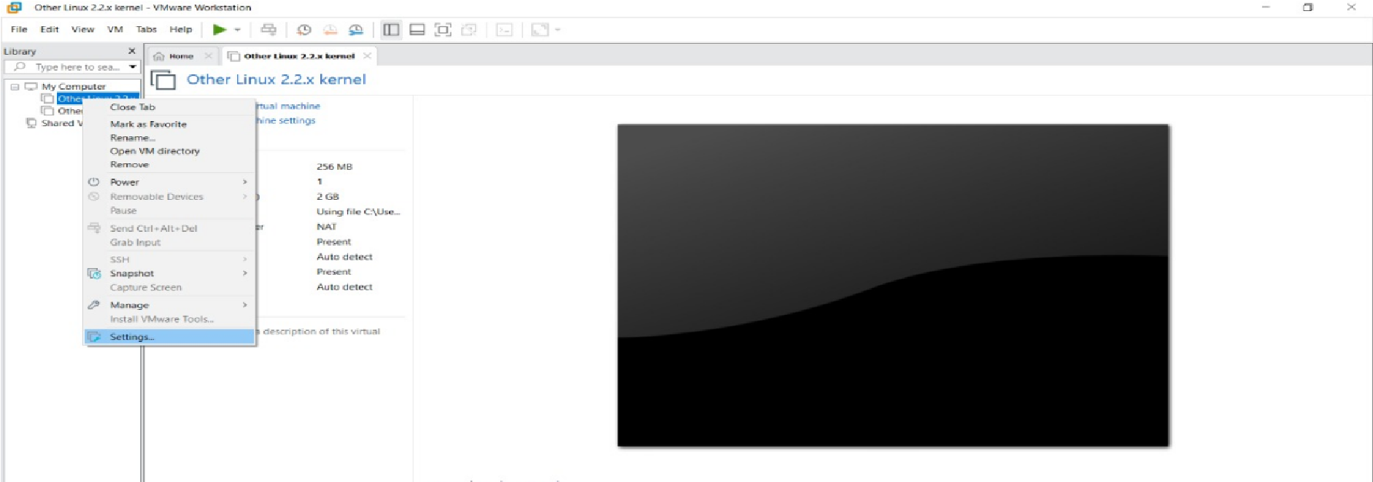 **STEP 3: ADD HARDWARE WIZARD AND SELECT SCSI AND CLICK NEXT**

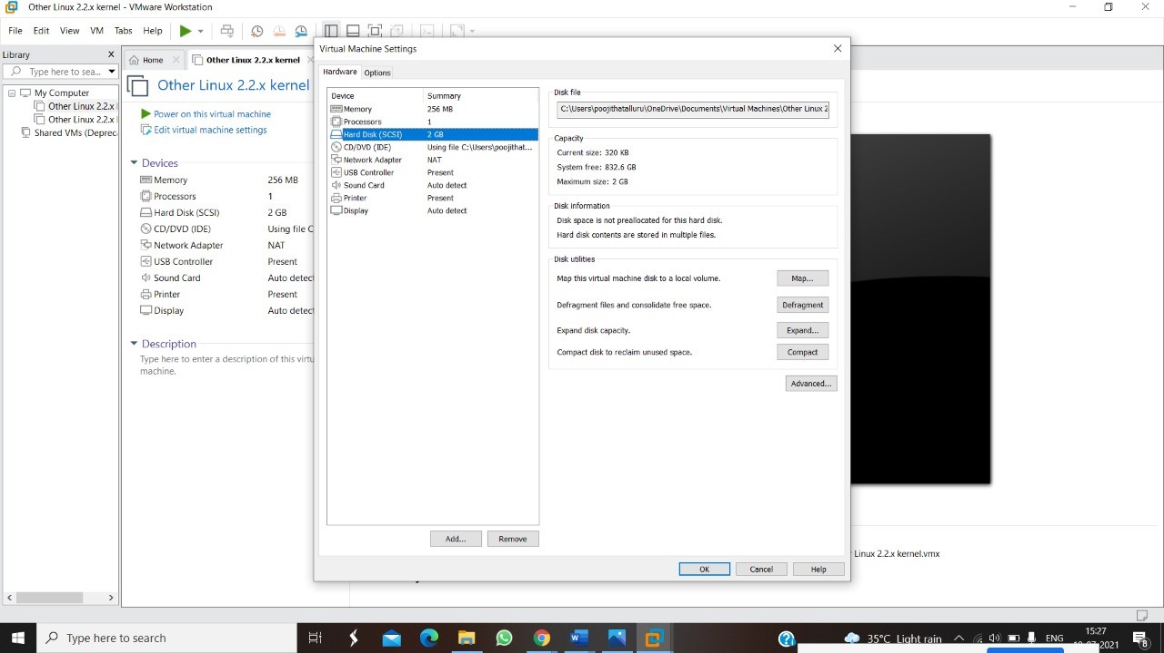

**STEP 4: CREATE NEW VIRTUAL DISK**

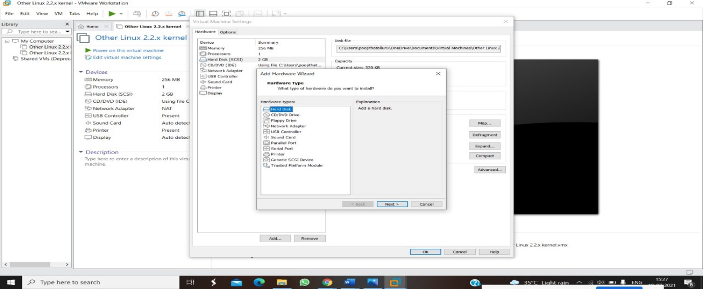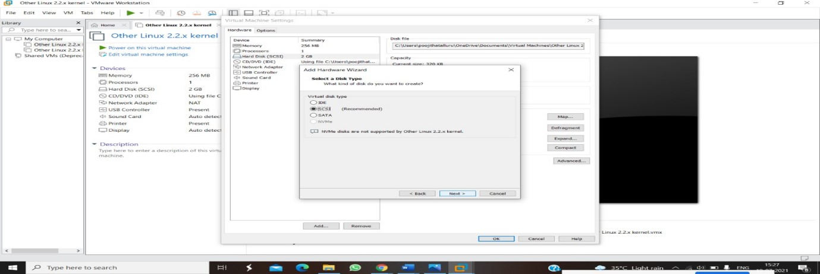 **STEP 5: SELCT THE DISK SIZE AS 2.0. AND SELCT SPLIT VIRTUAL DISK INTO MULTIFILES.**

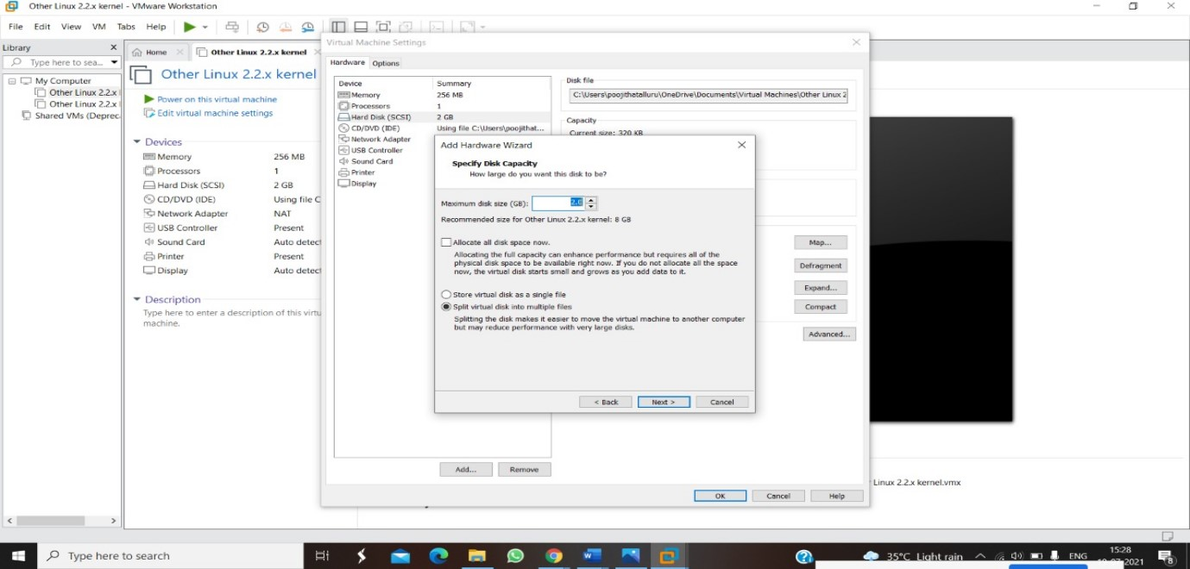 **STEP 6: GIVE NAME AND CLICK THE FINISH**

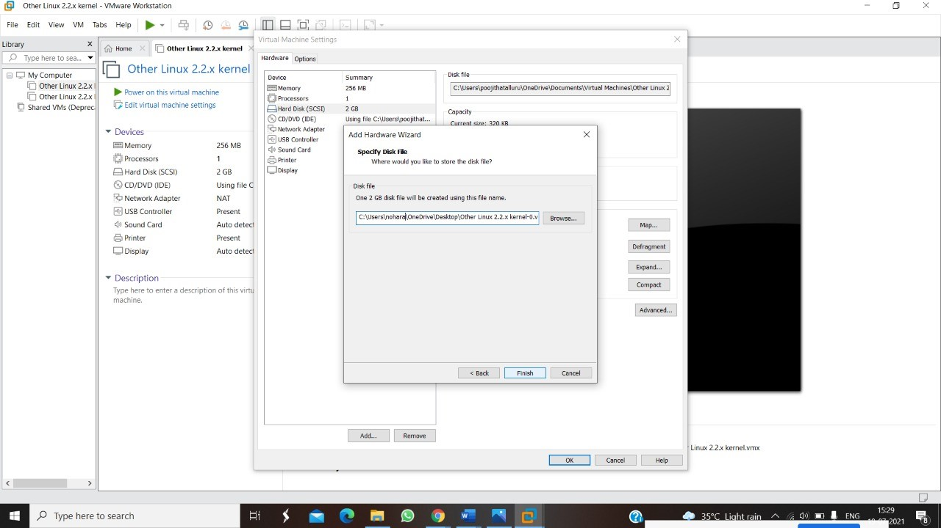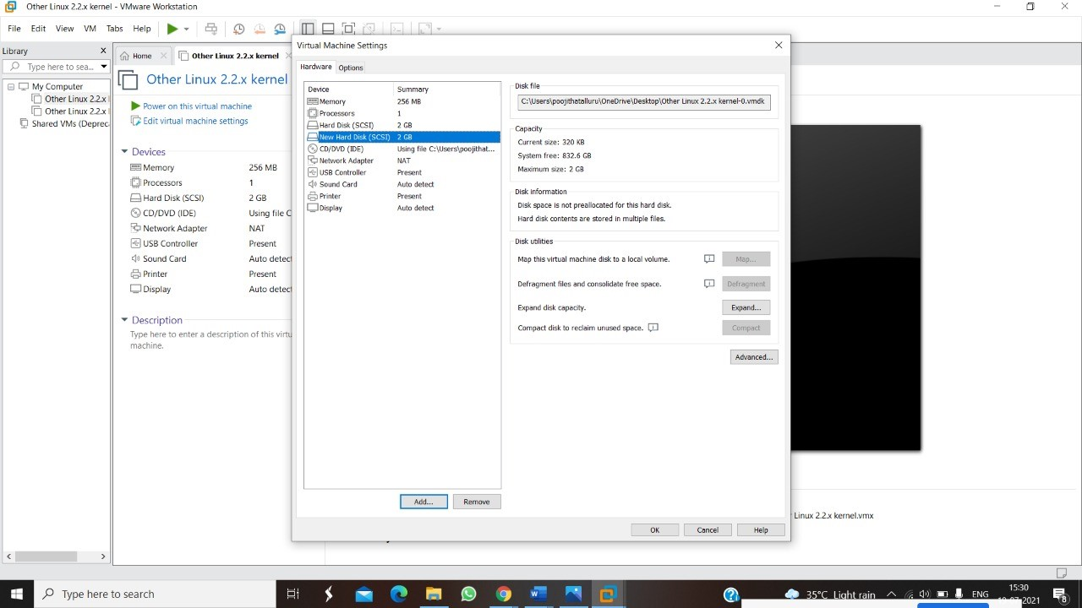

**RESULT:a virtual hard disk is being created using given specifications.**